1.3.
a)

nx=-3:1:7;
x=[0 0 0 2 0 1 -1 3 0 0 0];
stem(nx,x)
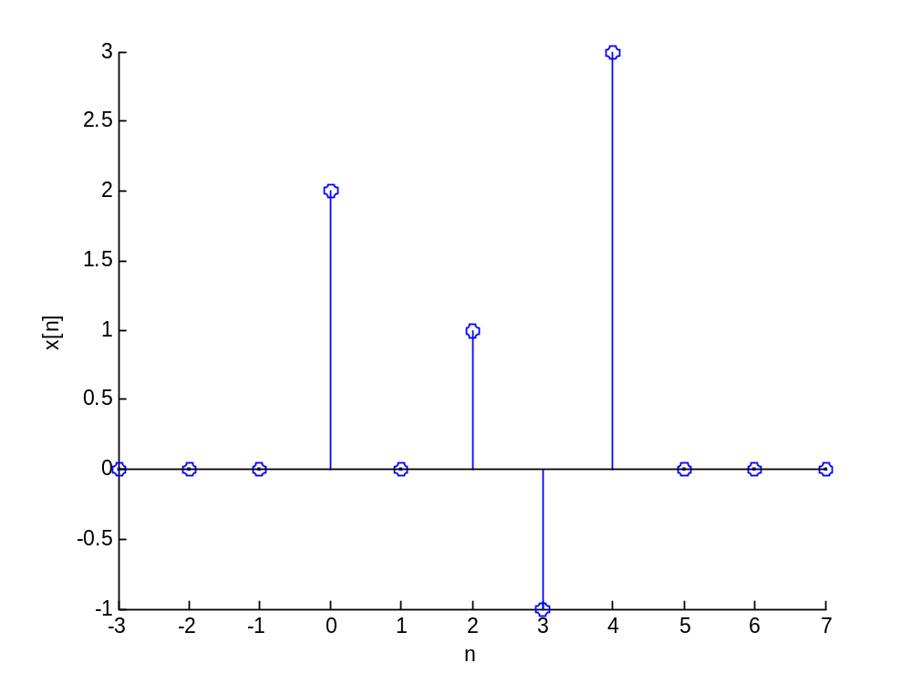

1.3.
b,c)

ny1=-1:1:9;
ny2=-4:1:6;
ny3=-3:1:7;
ny4=-4:1:6;
y1=[0 0 0 0 0 2 0 1 -1 3 0];
y2=[0 0 2 0 1 -1 3 0 0 0 0];
y3=[-1 1 0 2 0 0 0 0 0 0 0];
y4=[3 -1 1 0 2 0 0 0 0 0 0];

stem(ny1,y1)
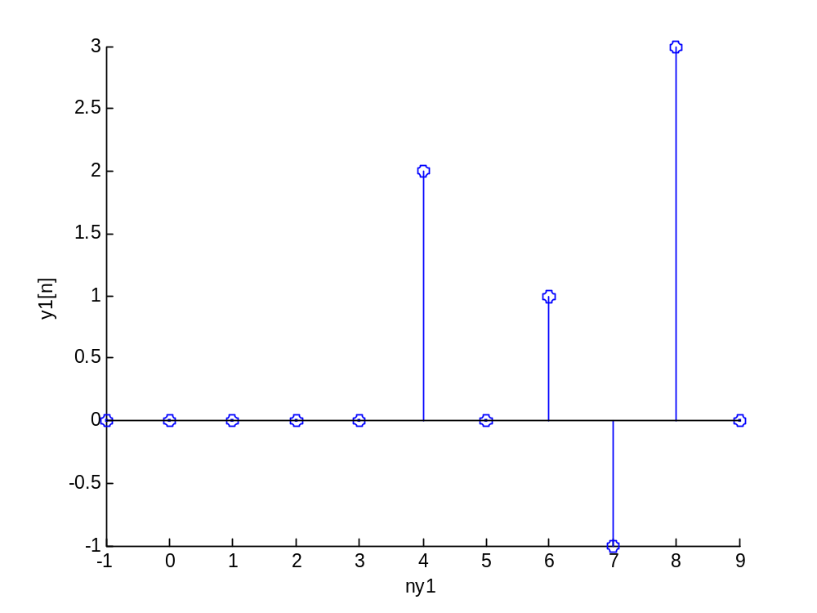
Delayed by 2.

stem(ny2,y2)
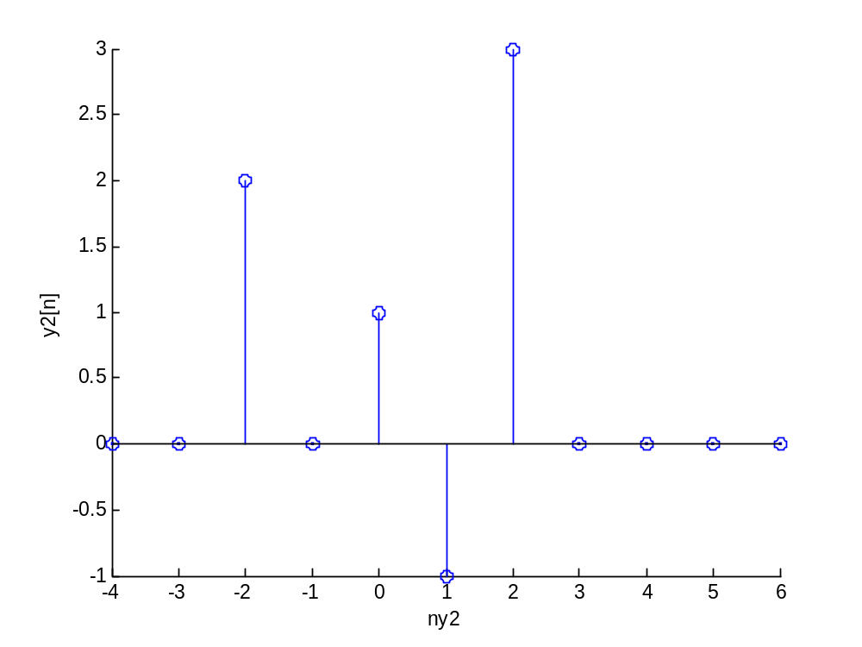
Advanced by 1.

stem(ny3,y3)
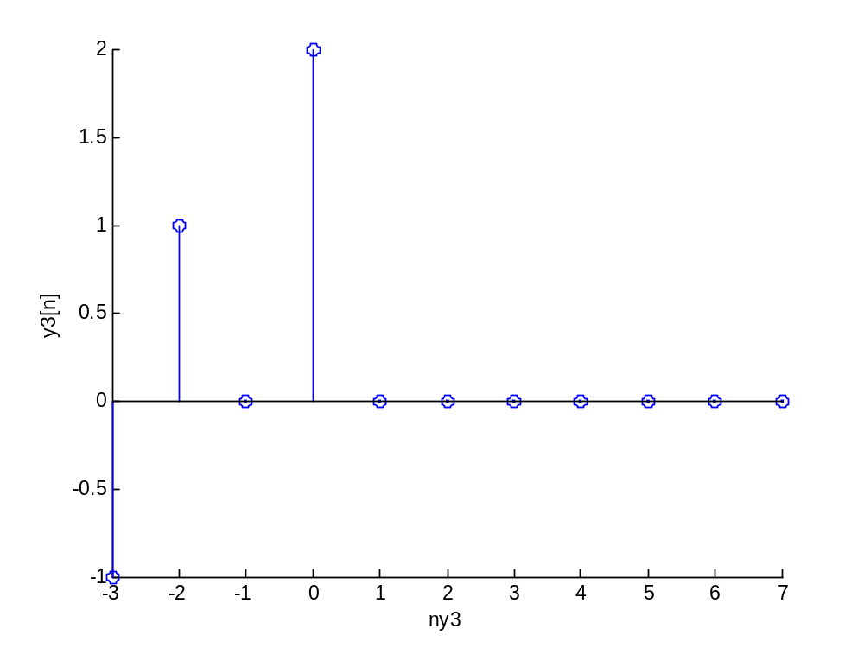
Flipped.

stem(ny4,y4)
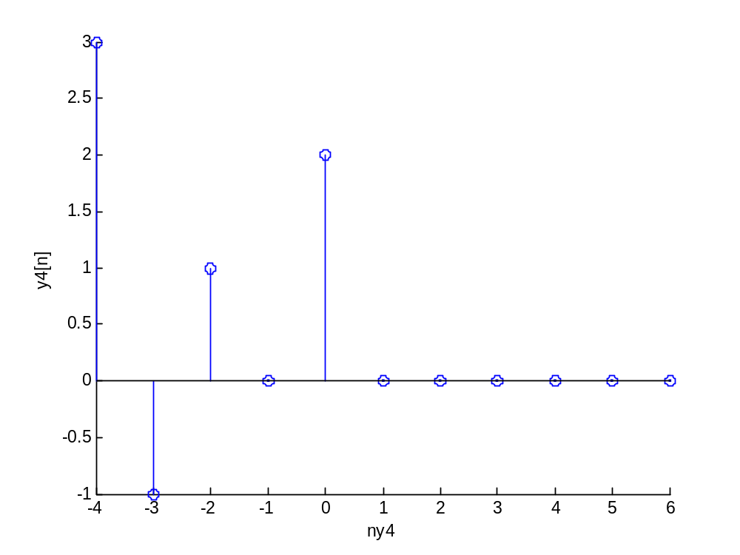
Flipped and Advanced by 1.

2.
a) n=0:1:10;
y=conv(x,x);
ny=n;
stem(ny,y)
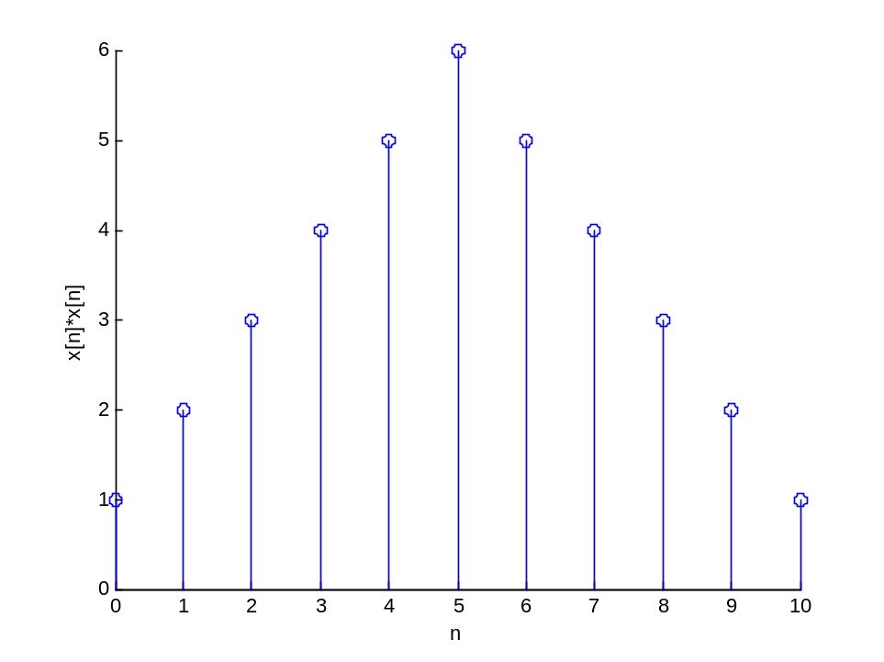
b) n=0:1:10;
h=[0 1 2 3 4 5];
y=conv(x,h);
stem(ny,y)

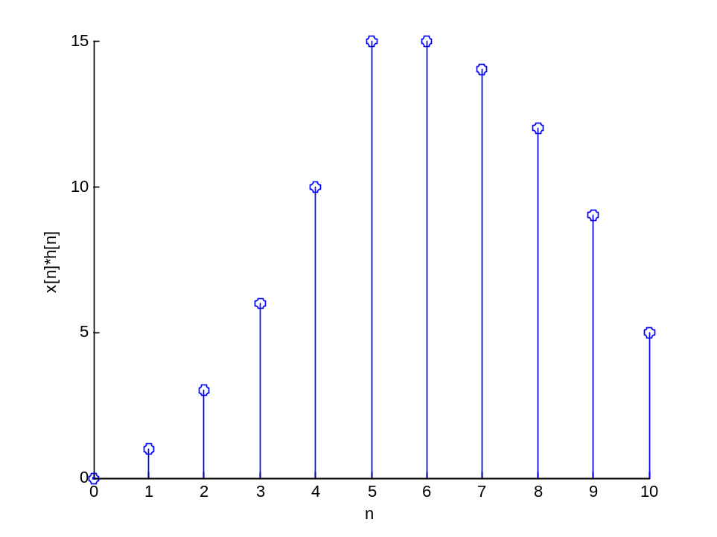
2.2.(tutorial).
including part d);
a)
a1=[1];
b1=[0.5 1 2];

y1=filter(a1,b1,x)

y1 =

2 0 -2 12

y1=filter(b1,a1,x)

y1 =

0.5000 2.0000 5.5000 9.0000

b)d)
a2=[1]
b2=[0.8 2]

y2=filter(b2,a2,x)

y2 =

2.0000 5.6000 10.4800 16.3840

c)d)
b3=[1 -0.8];
a3=[0 2];

y3=filter(a3,b3,x)

y3 =

0 2.0000 5.6000 10.4800

2.7.
a)
h=[0 2 0 -2 0];
x=[0 0 1 0 1];
y=conv(h,x);
ny=1:1:9;
stem(ny,y);

